

**Solution**

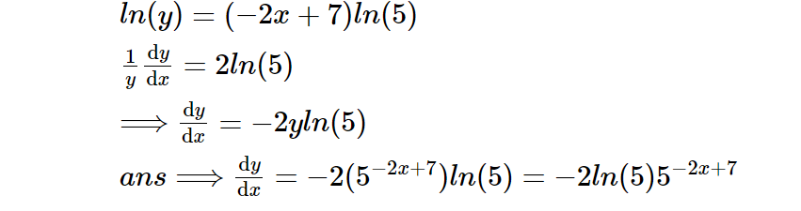



**Solution**

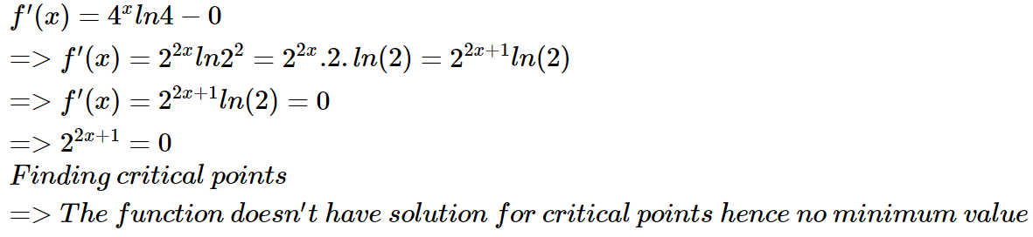



**Solution**

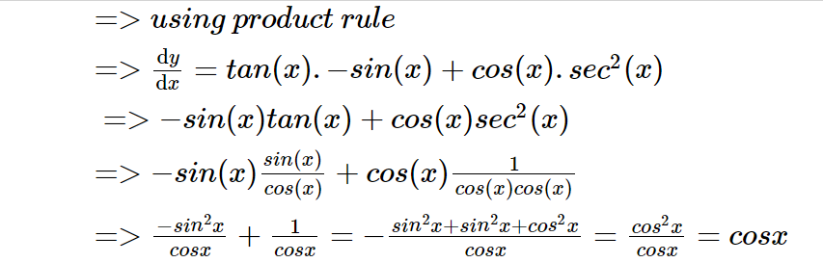

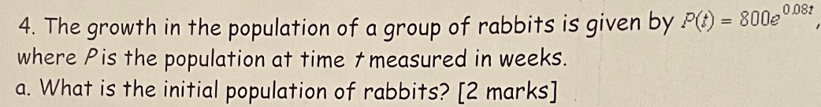

**Solution**

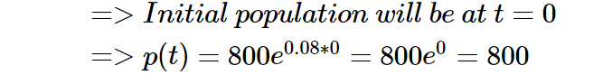



**Solution**

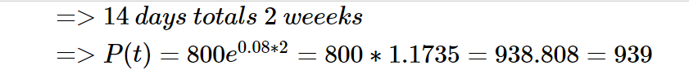



**Solution**

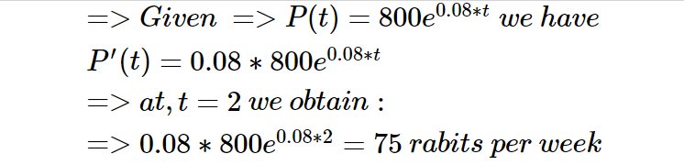

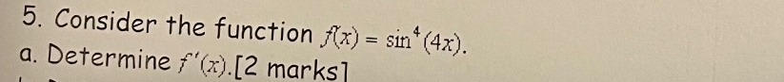

**Solution**

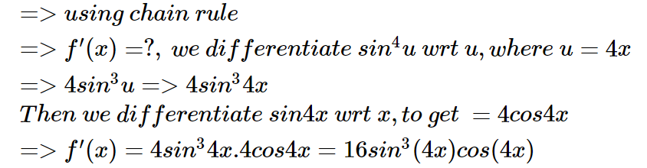



**Solution**

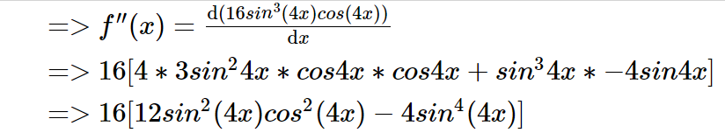

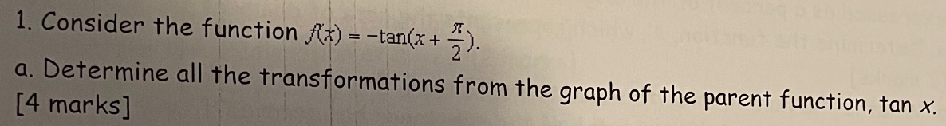

**Solution**

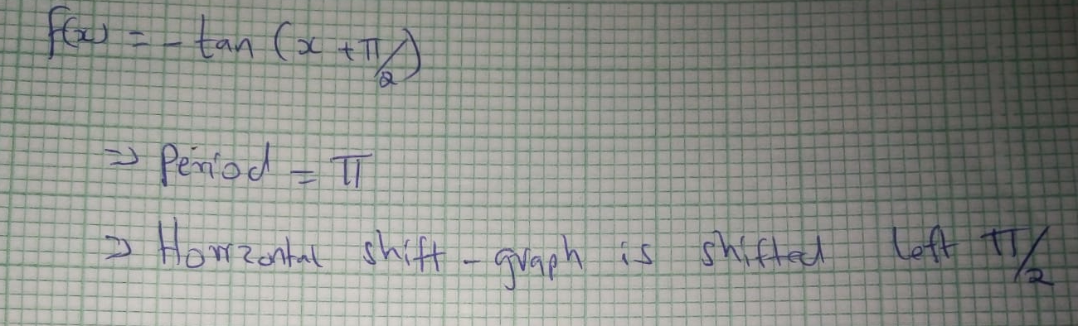

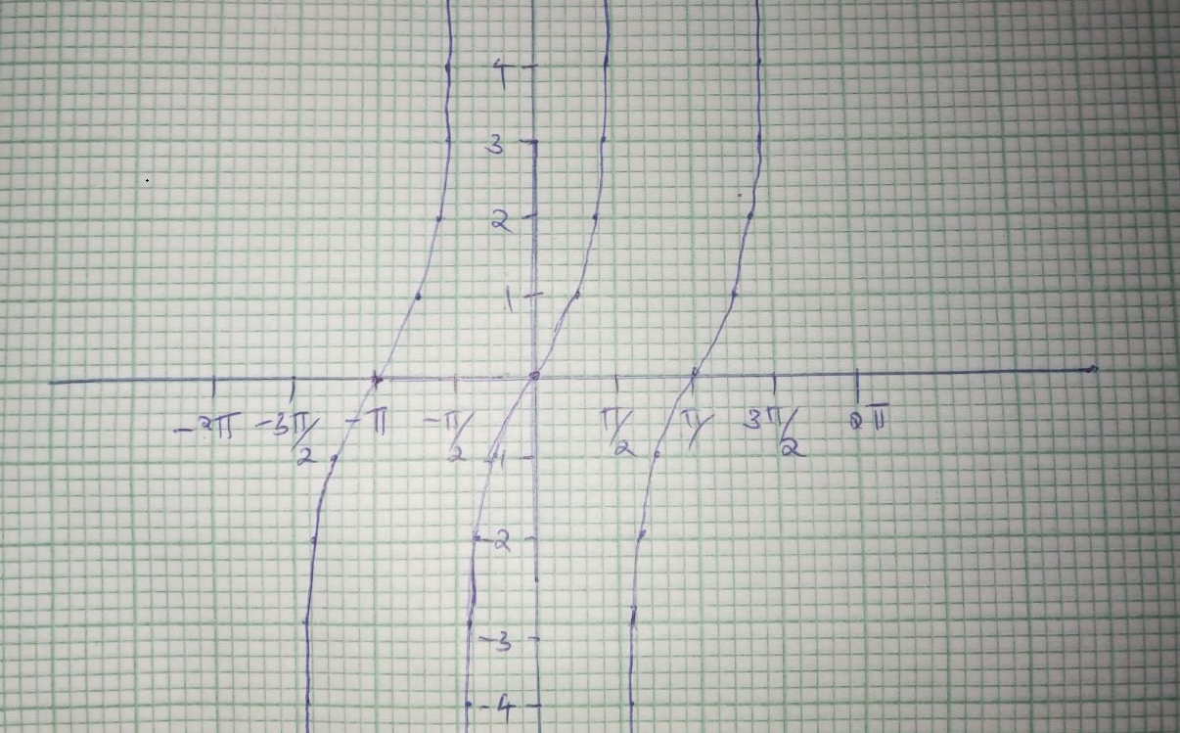



**Solution**

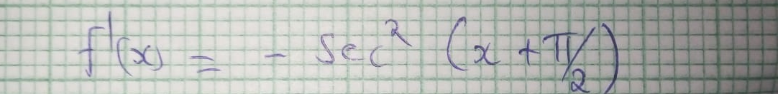



**Solution**

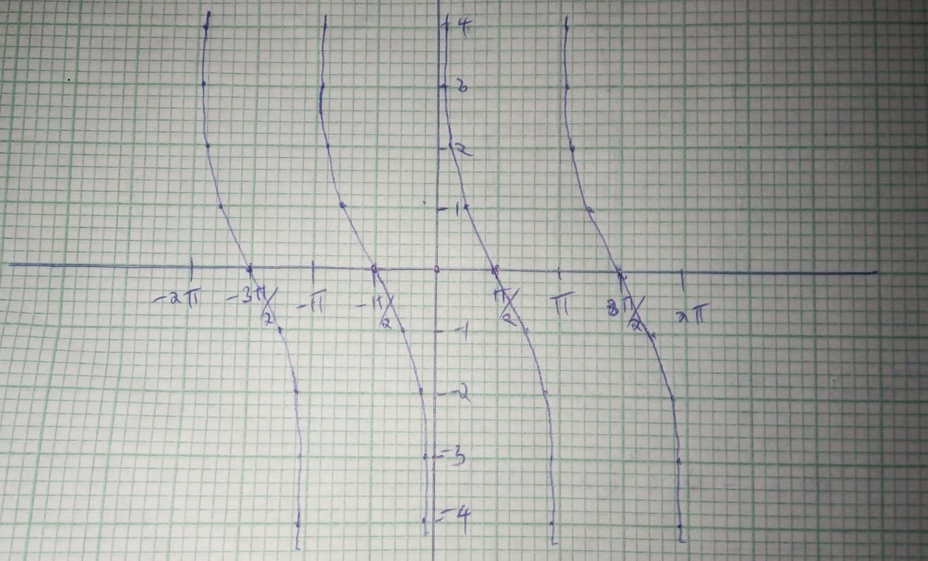

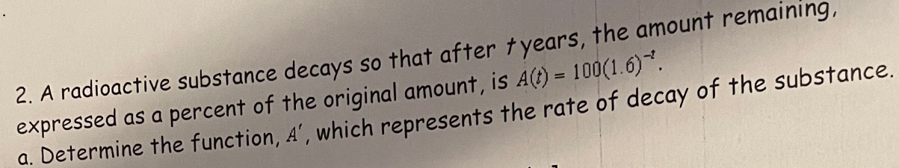

**Solution**

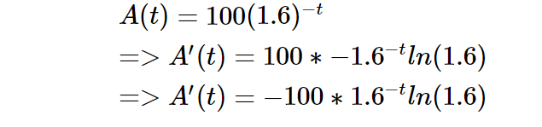



**(b)**

**Solution**

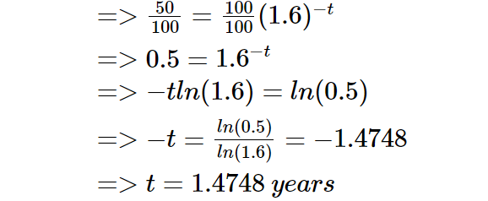

**©**

**Solution**

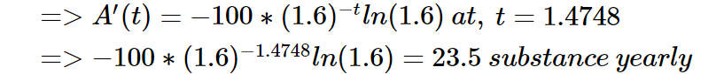

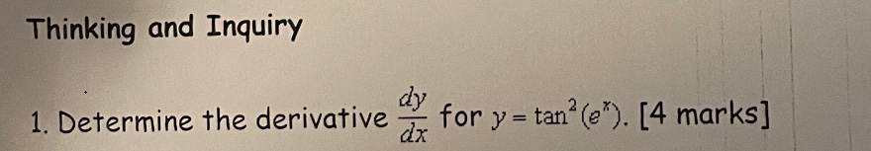

**Solution**

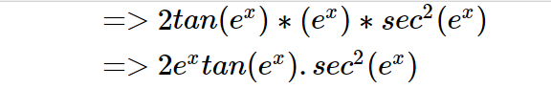

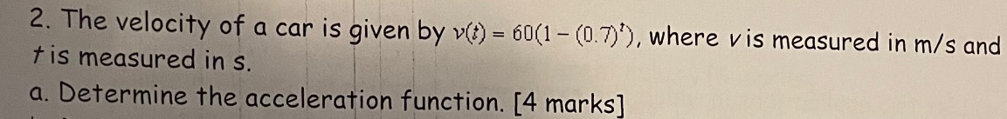

**Solution**

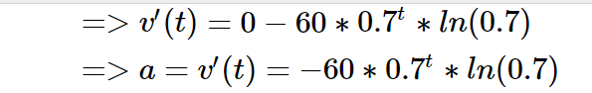



**Solution**

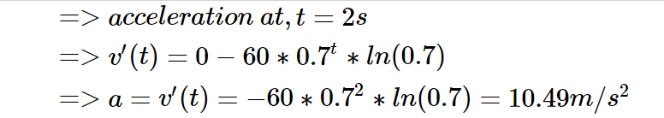



**Solution**

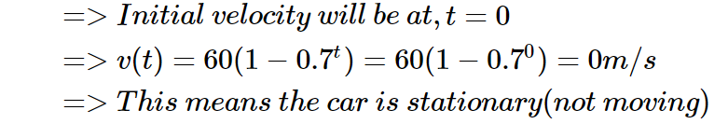



**Solution**

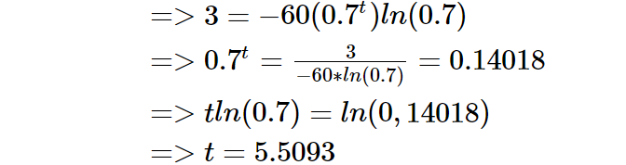



**Solution**

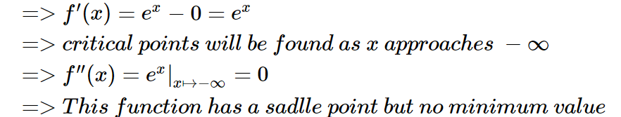

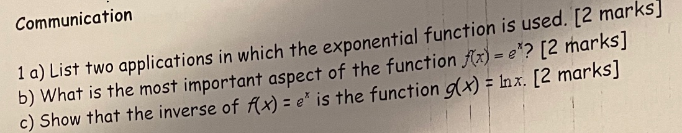

**(a)**

**Solution**





**(b)**

**Solution**





**©**

**Solution**

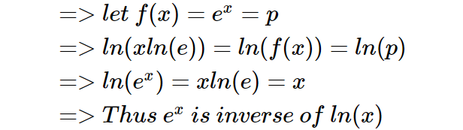



**Solution**











**Solution**







**Solution**





**Solution**

1. One way would be to differentiate the function csc(x) directly to obtain -cot(x)csc(x) by the use of the first principle of derivatives that is with the definition of limits
2. Second would be to use chain rule to differentiate the function using certain trigonometric properties and identities



**Solution**

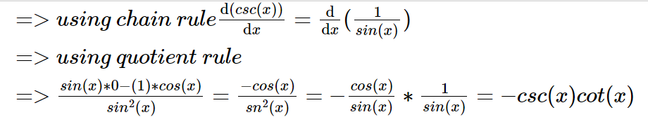

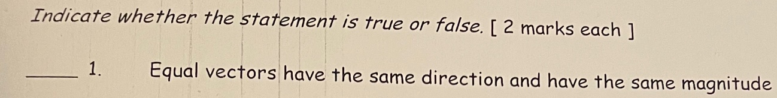

**True**



**False**



**False**



**True**



**True**

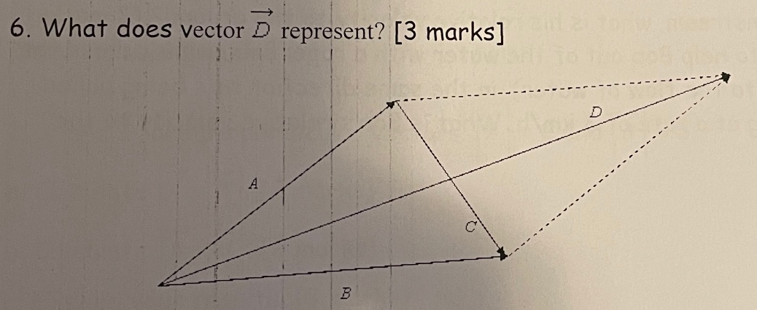

**Solution**

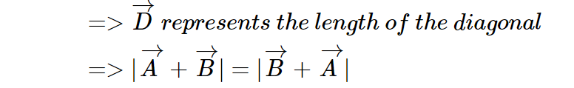



**Solution**

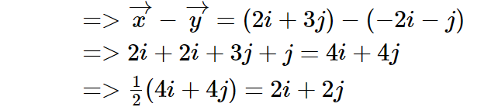

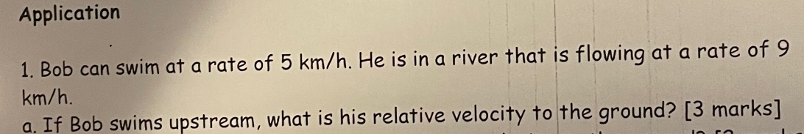

**Solution**

**9km/h-5km/h=4km/h**



**Solution**

**9km/h+5km/h=14km/h**

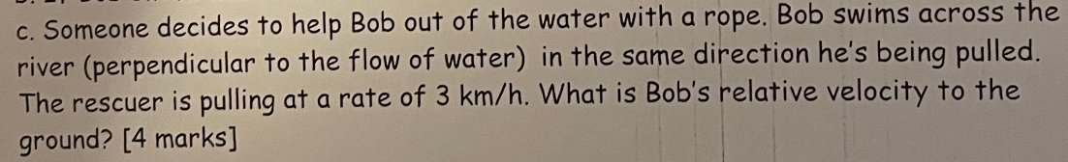

**Solution**





**Solution**

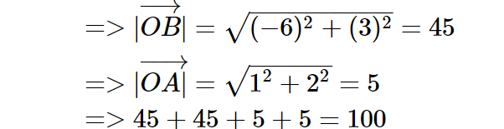



**Solution**

**Area=45*5=225 sq. units**



**Solution**



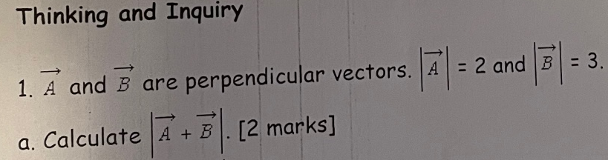

**Solution**





**Solution**





**Solution**

**Both vectors A and B has a positive resultant vector of 5 units whilst their difference results into a negative vector of -1 units implying that their positional vector coordinates will be much influenced by the directions of both vectors**

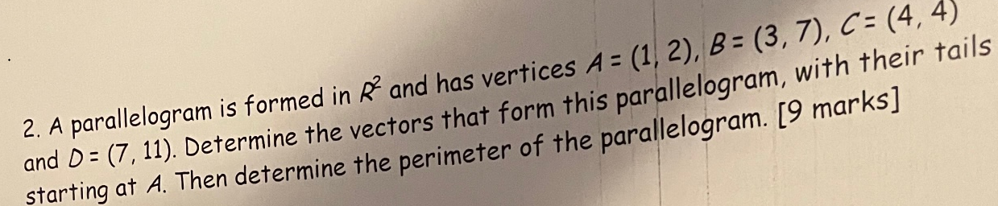

**Solution**

1. **Determine the vectors**

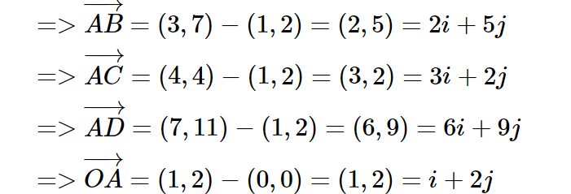

1. **Perimeter**

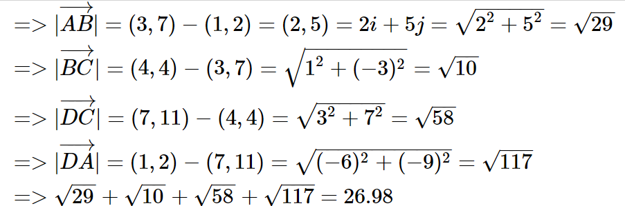

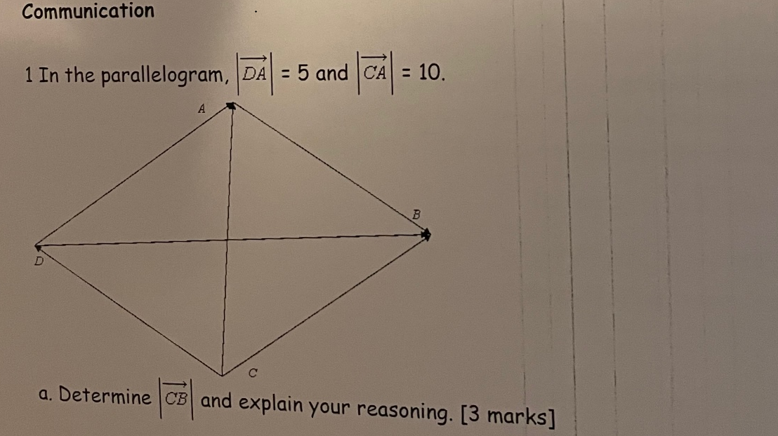

**Solution**





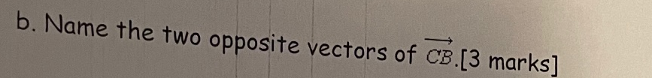

**Solution**

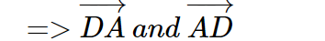



**Solution**

**Since |CA|=10, it implies that |AC| is also the magnitude of vectors AC and CA will be always equal regardless of the direction**

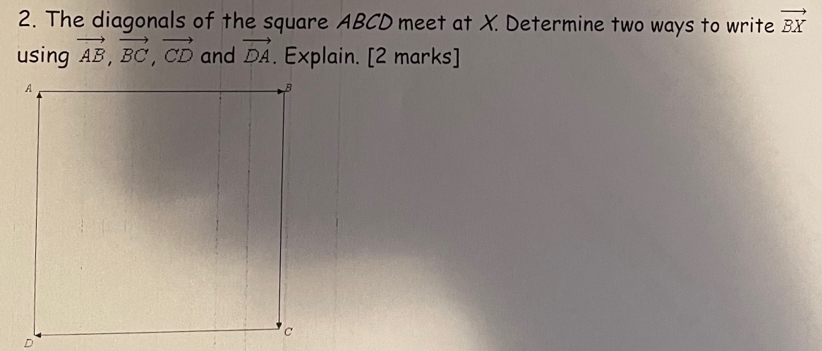

**Solution**

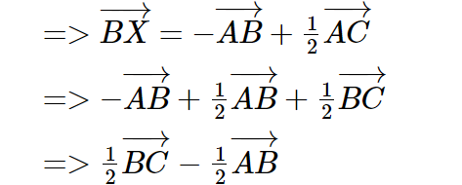

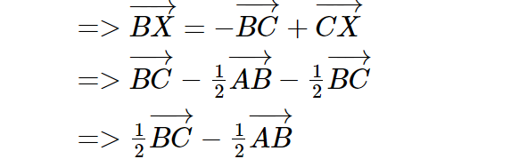

**To find the 2 ways we need to first calculate the diagonal AC equivalence, in terms of the given vectors**

**Then we split the diagonal to obtain any vector to the point X, Lastly we take the two possible ways which will result to BX as shown above**

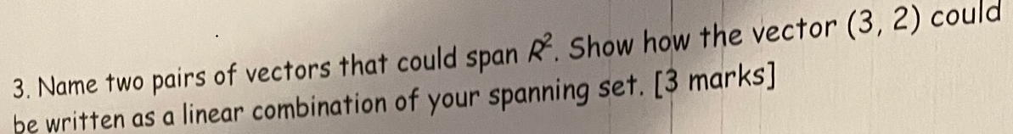

**Solution**

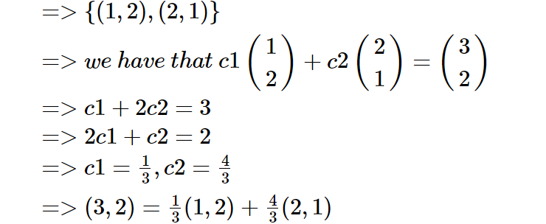

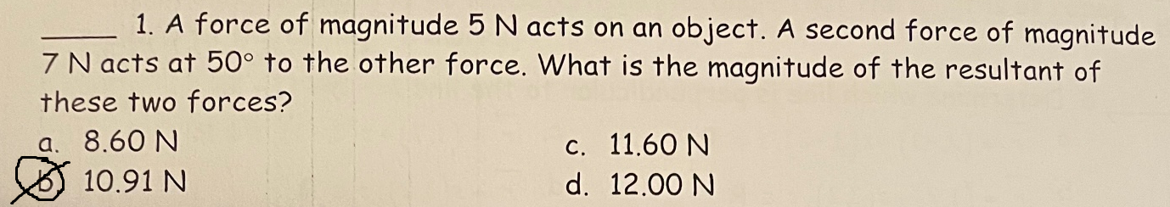

**b**

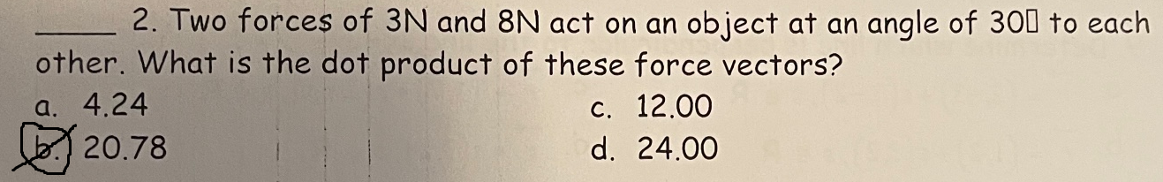

**b**

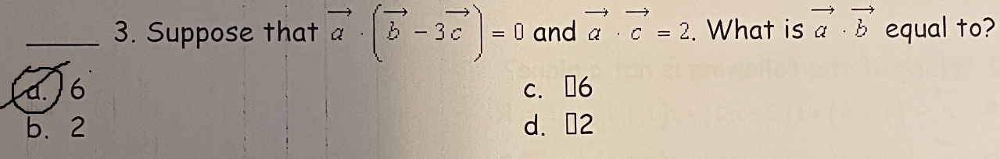

**a**

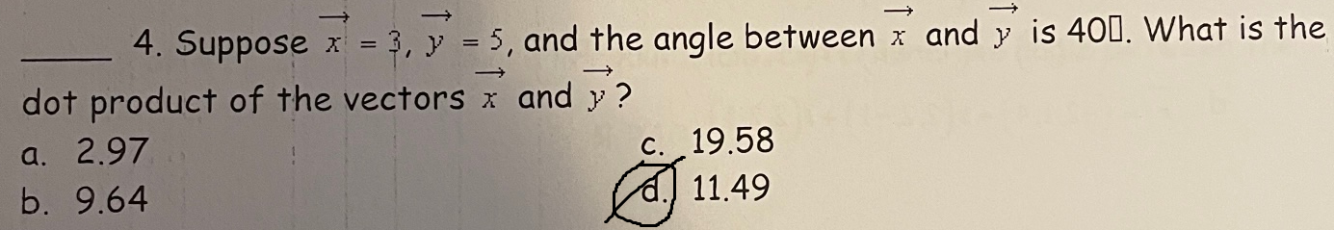

**d**

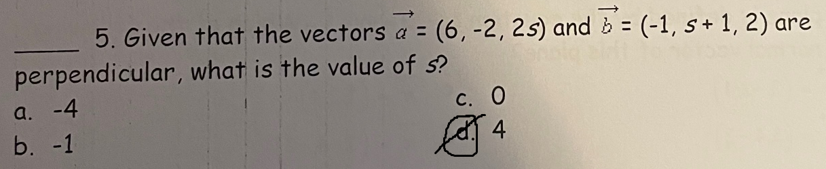

**d**

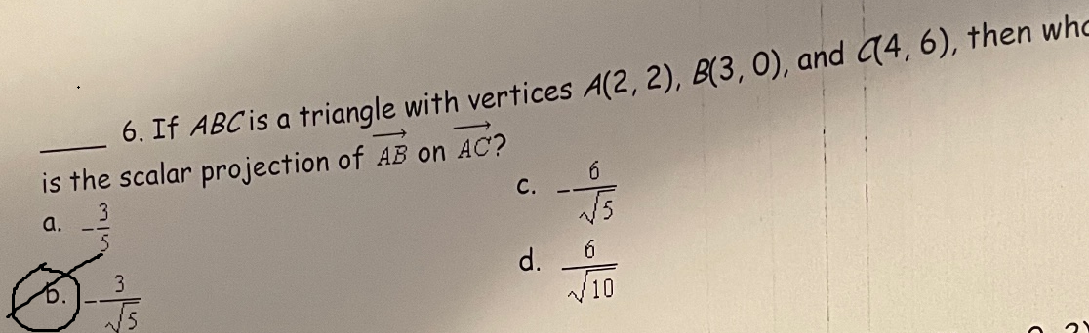

**b**

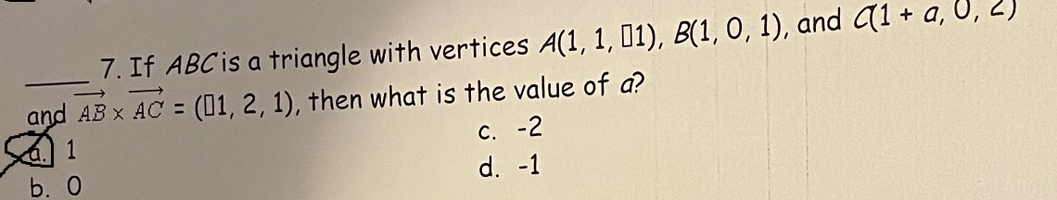

**a**

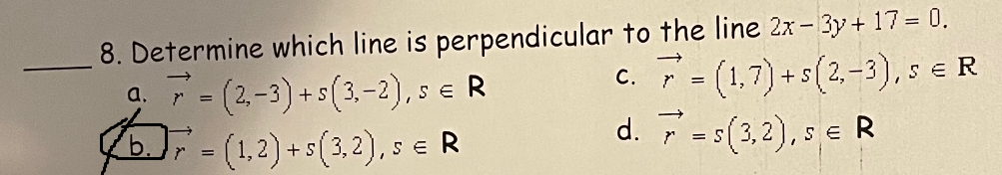

**b**

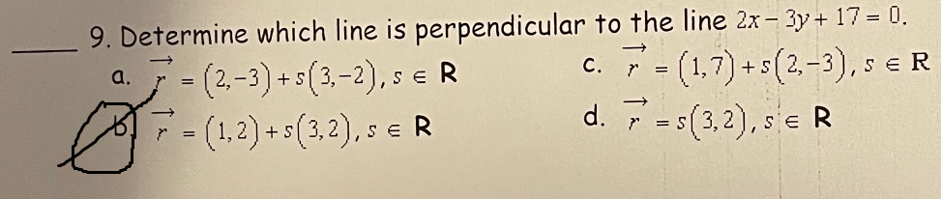

**b**

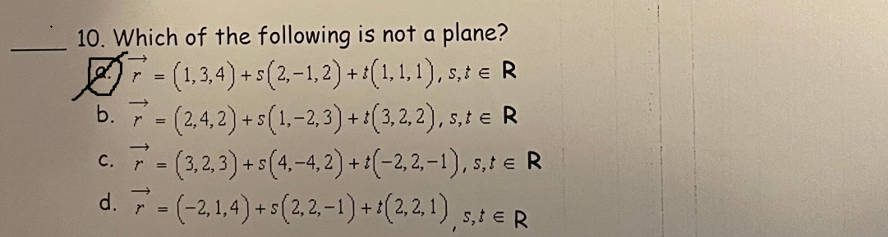

**a**

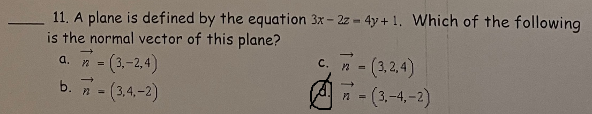

**d**

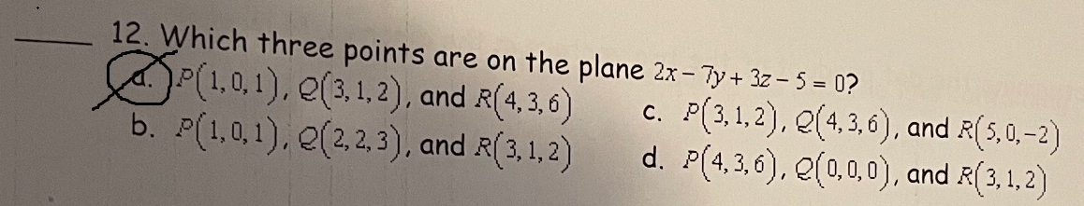

**a**

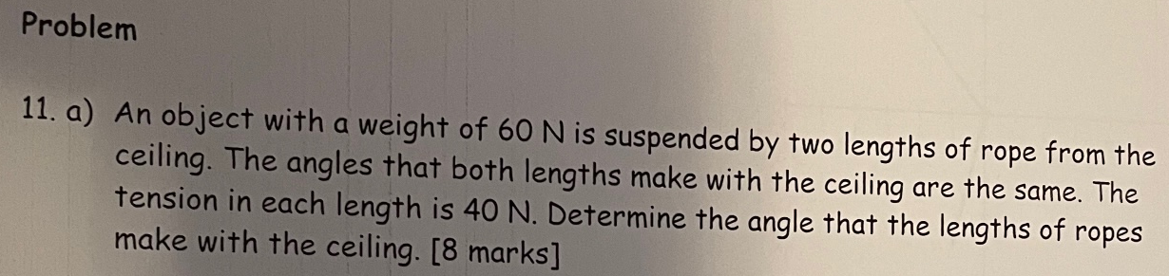

**Solution**

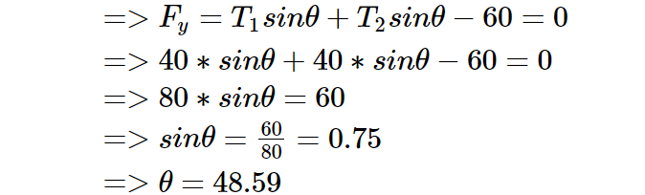

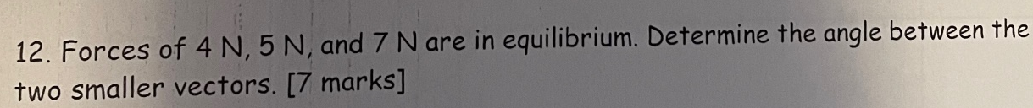

**Solution**

**For force in equilibrium, the sum of the 2 smaller forces must be equal to the 3rd force**

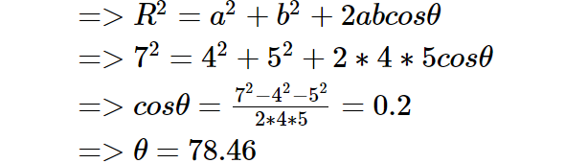

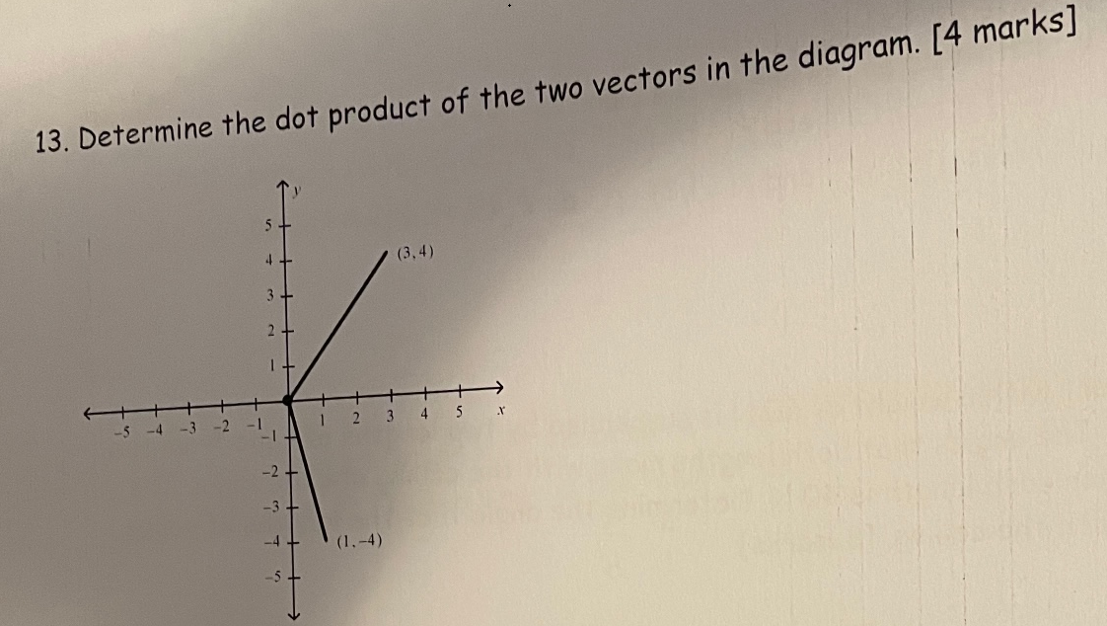

**Solution**

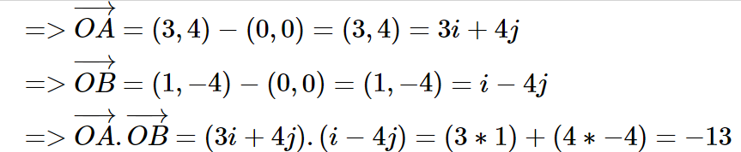

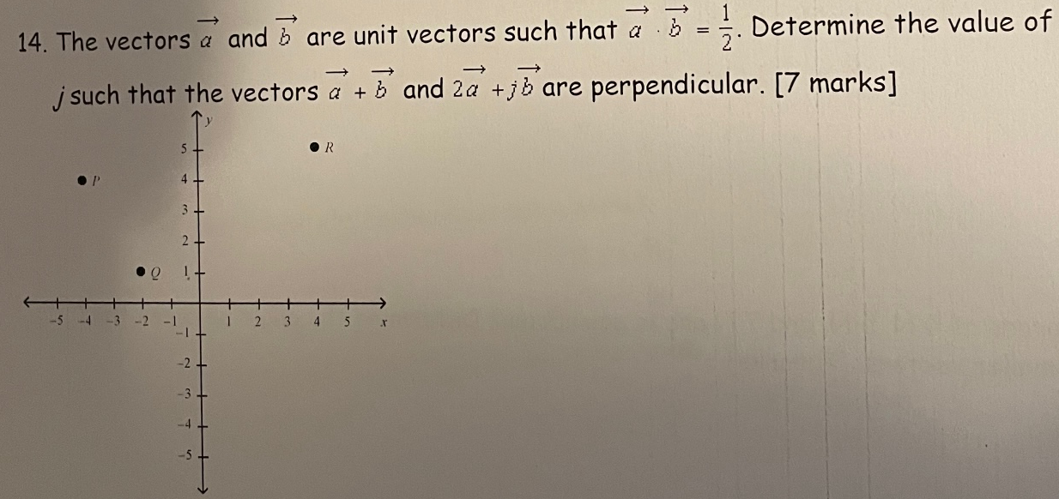

**Solution**

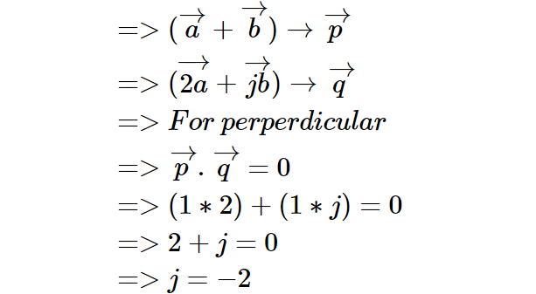

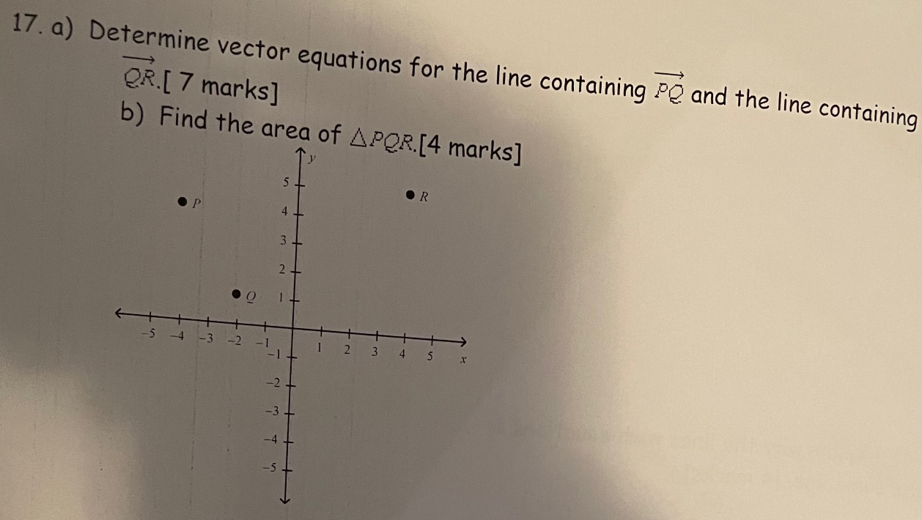

**Solution**

**a)**

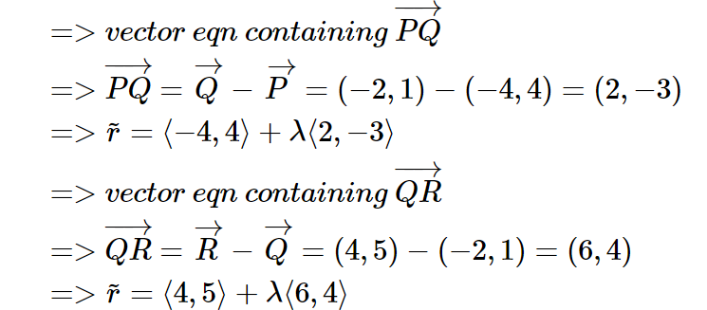

**b)**

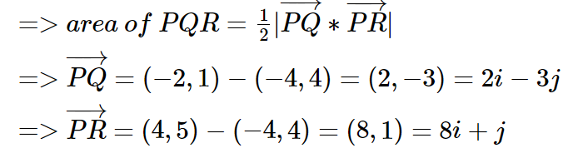

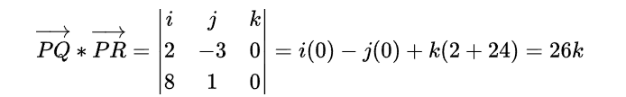



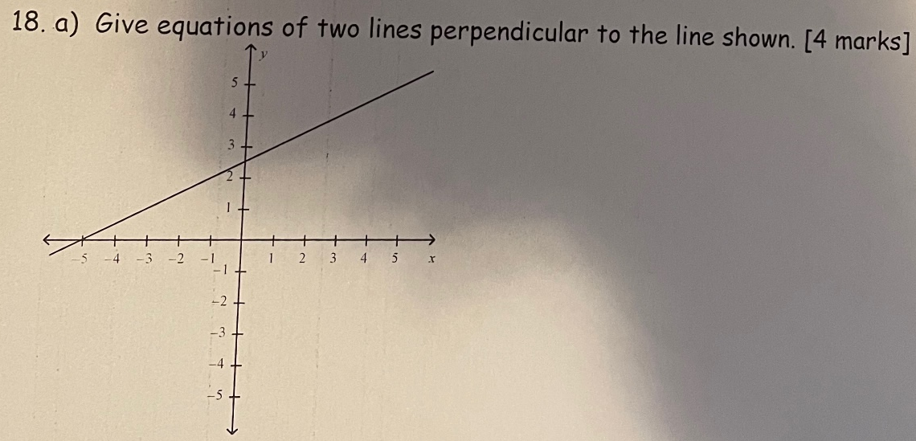

**Solution**

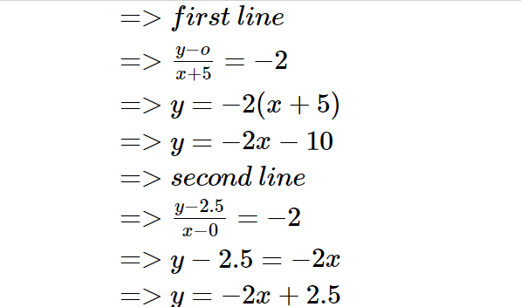

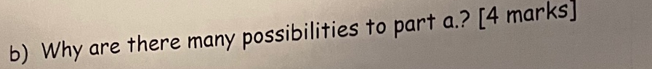

**Solution**

**This is because we already know the gradient for any other line to be perpendicular to the line shown will be equal to -2, implying that we can obtain as many lines as possible at any given coordinate in which we find the slope and equate to -2**



**Solution**

**They are the same since the first line is just multiplied with a factor of -2 to obtain the second line. Thus, they are actually the same line with a different multiplication factor**



**Solution**

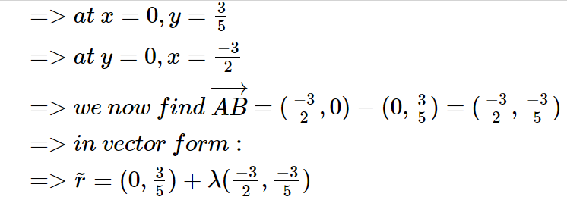

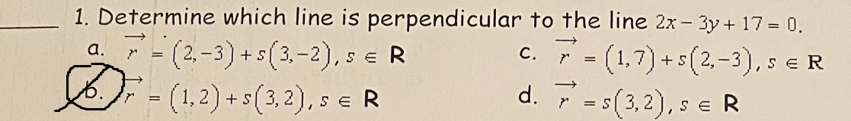

**b**

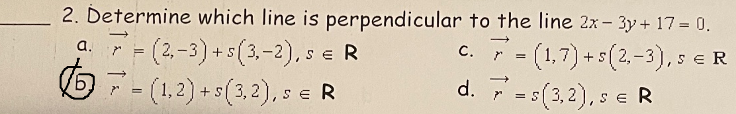

**b**

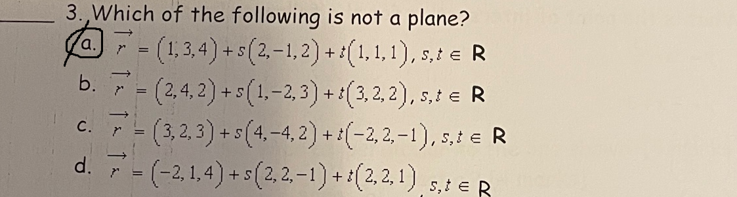

**a**

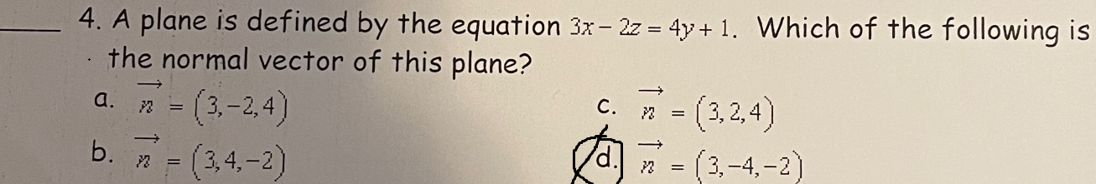

**d**

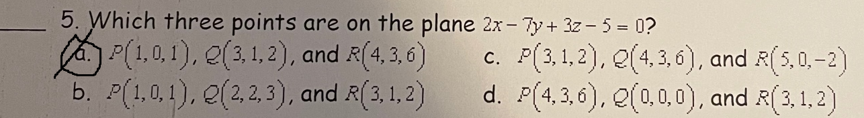

**a**

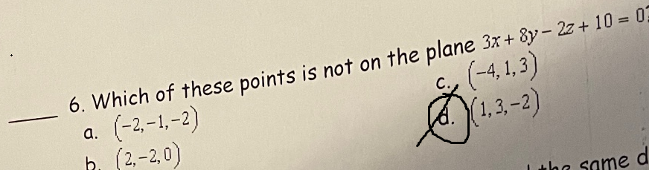

**d**

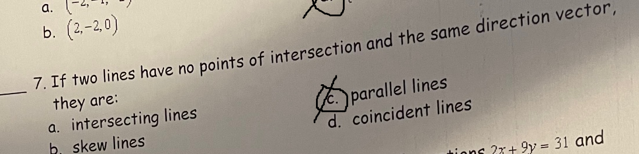

**c**

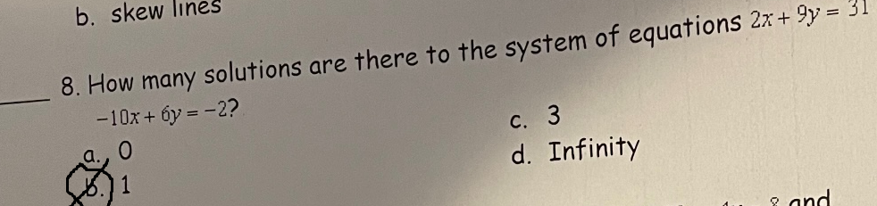

**b**

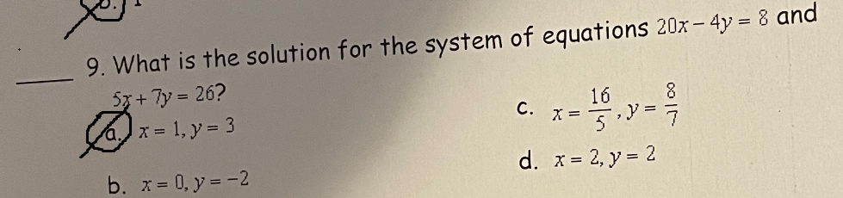

**a**

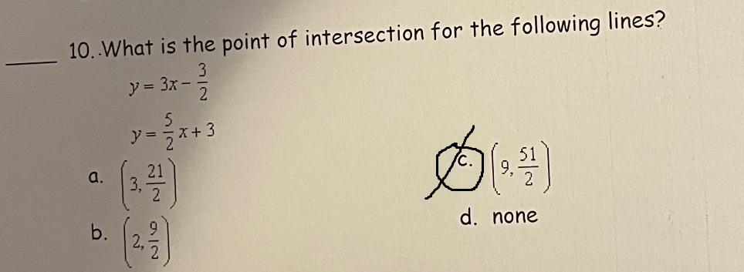

**c**

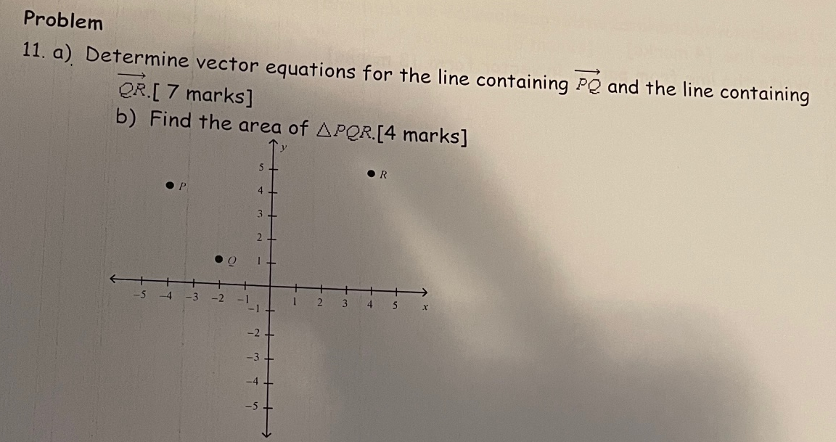

**Solution**

**a)**



**b)**









**Solution**



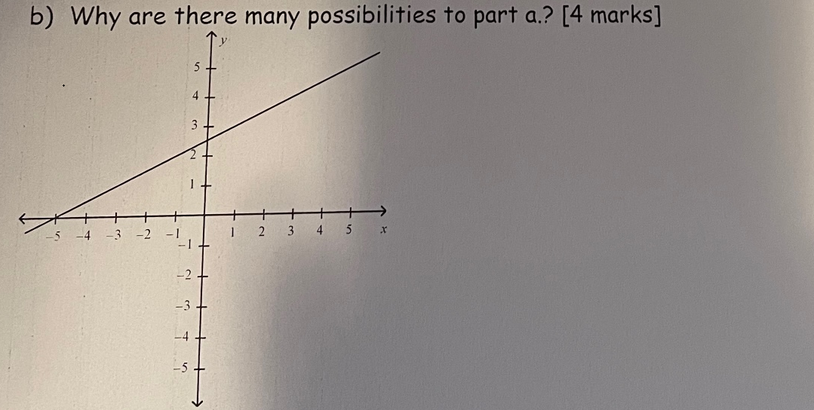

**Solution**

**This is because we already know the gradient for any other line to be perpendicular to the line shown will be equal to -2, implying that we can obtain as many lines as possible at any given coordinate in which we find the slope and equate to -2**

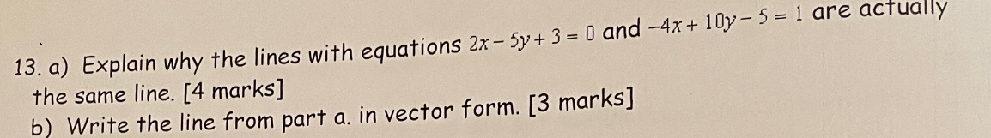

**Solution**

**a)**

**They are the same since the first line is just multiplied with a factor of -2 to obtain the second line. Thus, they are actually the same line with a different multiplication factor**

**b)**



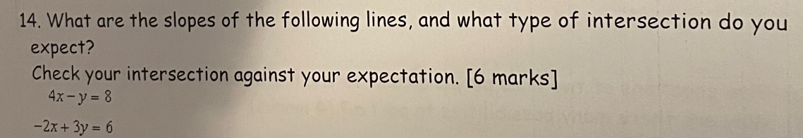

**Solution**

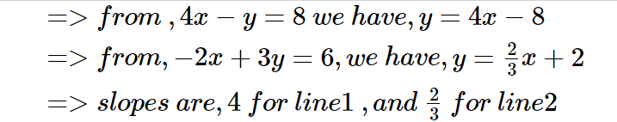

**The two lines intersect with each other at an acute angle on the positive first quadrant**

**Let’s check the angle of intersection using the slopes**

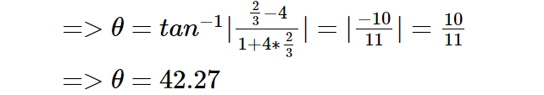

**This is correct as per the expectation being an acute angle with the first quadrant and its verified having an angle of 42.27**

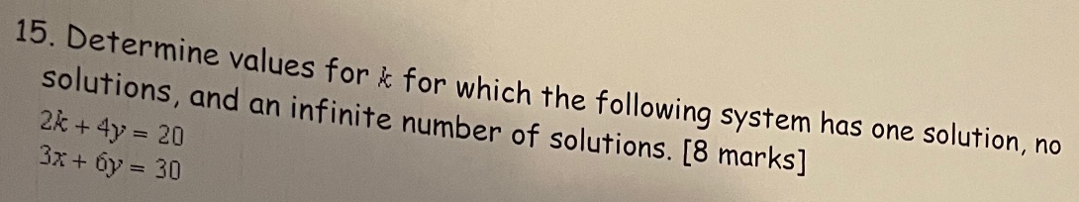

**Solution**



1. **No solution**

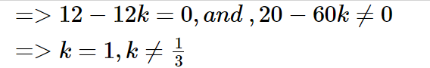

1. **One solution**

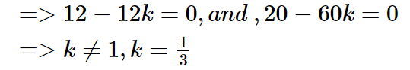

1. **Infinite solutions**

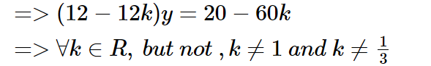

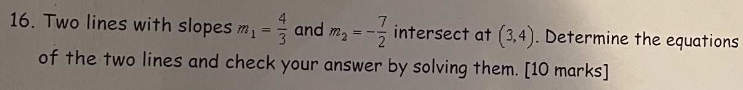

**Solution**

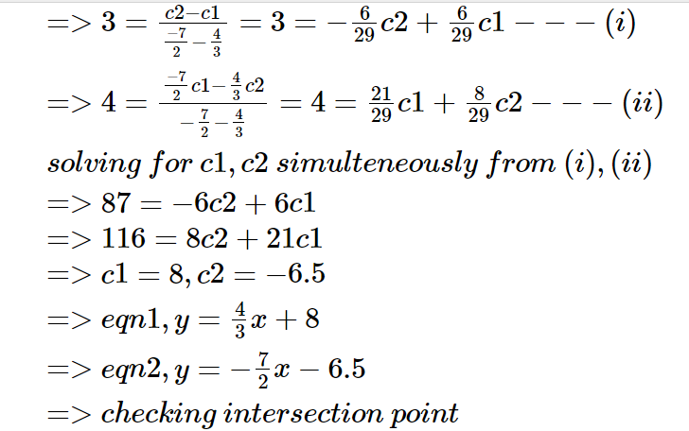

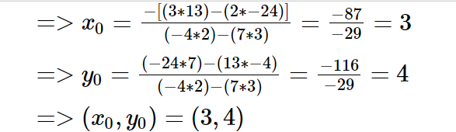

**THE END**